Advanced Operating Systems Design – Spring 2022
Quiz 6 (04/07/2022)

Student Name: ______________ (First Last)
Student R#: ______________
Score: _______________ (Total: 3%)

Question 1: (1%) Page replacement algorithms
Given the hardware implementation of Least Recent Used (LRU) for 4 pages: 0, 1, 2, and 3.
LRU using a matrix when pages are referenced in the order 0, 1, 2, 3, 2, 1, 0, 3, 2, 3 as shown below.
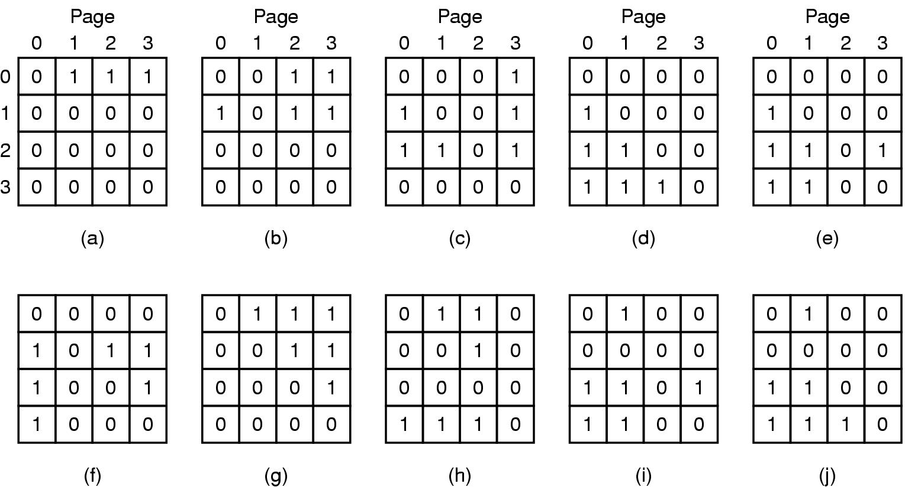
The next reference is page 1.
- Please draw the matrix when page 1 is referenced
- Assuming that we need to replace a page after page 1 is referenced, which page will be picked. Please explain your answer.

Question 2: (2%) Structured Peer-to-Peer Architectures
- Please discuss the pros and cons of Simple Routing vs. Chord Routing. (1%)
- In a P2P network with 2,048 possible nodes, How many entries in the routing table (of each computer) if we are using Simple Routing vs. Chord Routing. Please explain your answers. (1%)

